**Cardiology Department Website**

Team:2

Submitted to: **Dr Ahmed Hisham / Eng Abdallah Darwish**

|  |  |
| --- | --- |
| Name | BN |
| Judy Essam | 19 |
| Habiba Alaa Eldin | 20 |
| Maya Mohamed Abdelfattah | 51 |
| Mostafa Ali | 61 |
| Youssef Mohamed Abo-El-Ela | 77 |

Table of Contents

1. Introduction: 3

2. Project Required Features: 3

3. Project Additional Features: 9

4. Future Work: 12

## Introduction:

## Background Information

The Cardiology Department is a critical branch of medical science dedicated to diagnosing, treating, and preventing diseases related to the heart and blood vessels. With cardiovascular diseases being one of the leading causes of mortality worldwide, the role of cardiology has never been more significant. Advancements in medical technology, coupled with a deeper understanding of cardiovascular conditions, have allowed cardiology departments to offer comprehensive care that encompasses everything from preventive measures to complex surgical interventions.

#### Objectives

Our website aims to streamline healthcare interactions by providing a comprehensive and user-friendly platform for patients, doctors, and administrators. Patients can effortlessly manage appointments, view test results, communicate with doctors, and receive medical receipts via email, while doctors can efficiently track appointments, access patient details, add notes, and manage their schedules. Additionally, administrators can add doctors and track the entire hospital database to ensure smooth operations. Through these features, we strive to enhance the overall healthcare experience, fostering better communication, organization, and personalized care.

#### Scope

This project encompasses the development of a fully functional website for the Cardiology Department, including the following features:

1. **Homepage:** An overview of the department, doctors, services provided, and contacts.
2. **Patient Profile: A Profile for each patient includes his general information, medical records and history, appointment details, and messaging with doctors, ensuring keeping track to essential health information and enhanced communication.**
3. **Doctor Profile: A Profile for each doctor which contains the general information of him, appointment details, adding patient’s health conditions and messaging with patients.**
4. **Admin Profile: Profile for each admin in which he can add, edit, or remove a doctor from the database. Track the statistics and the database of the department.**
5. **Edit Page:** The doctor or patient can edit the general information in his profile.
6. **Login Page:** Through Which admin, doctor, and patient can log in to their accounts.
7. **Register Page:** Through Which patients can register a new account.

By implementing these features, the website aims to enhance the accessibility and quality of information available to patients and their families, support the healthcare team in providing excellent care, and promote cardiovascular health awareness in the community. Now Let’s take a detailed look at the features of our website.

## Project Required Features:

#### Homepage:

*Fig (1)*

The homepage offers several features, including a navigation bar. This navigation bar allows users to:

1. Navigate to different sections of the page including: about us, doctors, services and contacts.
2. Access the appointment booking page.
3. Log in to their profile.

Another feature is the image slider, which rotates through different photos as shown in fig(2) and fig(3)

*Fig (2)*

*Fig (3)*

The homepage also includes cards showing the services provided by the hospital. When the user hovers over a card, it displays detailed information about the service as shown in fig (4)

*Fig (4)*

These cards in fig (5) display the doctors in each department. When the user hovers over a card, it flips to reveal details about the doctor.

*Fig(5)*

#### Patient Profile:

*Fig (6)*

Through the patient profile, the Patient can:

1. Track their medical Records and files added by the doctor.
2. Send and receive messages to/from their doctor.
3. Track their appointments with the doctor and schedule a new appointment.
4. Change their general information.

#### Doctor Profile:

*Fig (7)*

Through Doctor Profile in fig(7), the doctor can:

1. Edit their general information.
2. Add or edit patient medical records. or add notes to the patient.
3. Send and receive messages to/from the Patient.
4. See their upcoming/ past appointments.

#### Admin Profile:

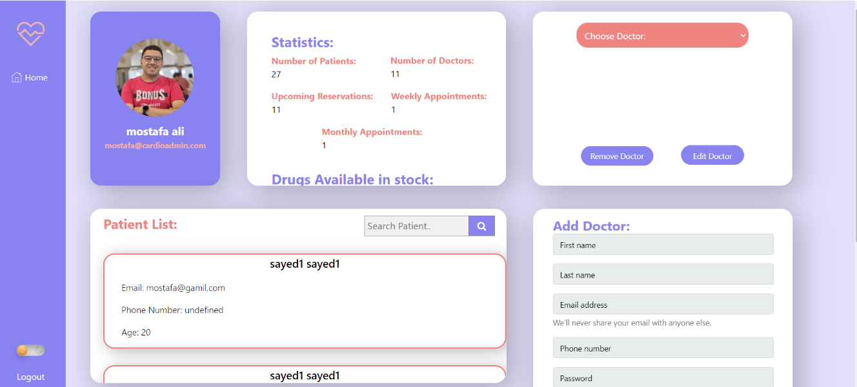

*Fig (8)*

*Fig (9)*

Through the admin page in fig(8) and fig(9), the admin can:

1. View Statistics regarding the department.
2. Add, edit, or remove doctors from the database.
3. See a List of registered patients and search for specific patients.
4. See a List of doctors and search for specific doctors.

#### Make Appointment Page:

*Fig (10)*

When the patient clicks the "Make Appointment" button in their profile, they are redirected to a page where they can select the doctor they wish to make an appointment with. The available appointments for the chosen doctor will then be displayed for the patient to choose from as shown in fig(10).

#### Login Page:

*Fig (11)*

The login page features a dynamic video background, providing users with the option to log in to their respective profiles as a doctor, admin, or patient as shown in fig(11)

#### Register Page:

*Fig (12)*

Patients can register a new account using the registration page. However, it is not possible for them to register as an admin or a doctor as in fig(12).

#### Edit Doctor:

*Fig (13)*

Doctors can update their profile information through this page in fig (13).

#### Edit Patient:

*Fig (14)*

Patients can change their profile information through this page in fig (14).

## Project Additional Features:

#### Dark mode:

*Fig (15) Fig(16)*

*Fig (17)*

*Fig (18)*

Users can experience our website using either dark mode or light mode as in fig (17) and fig(18).

#### Patient Details:

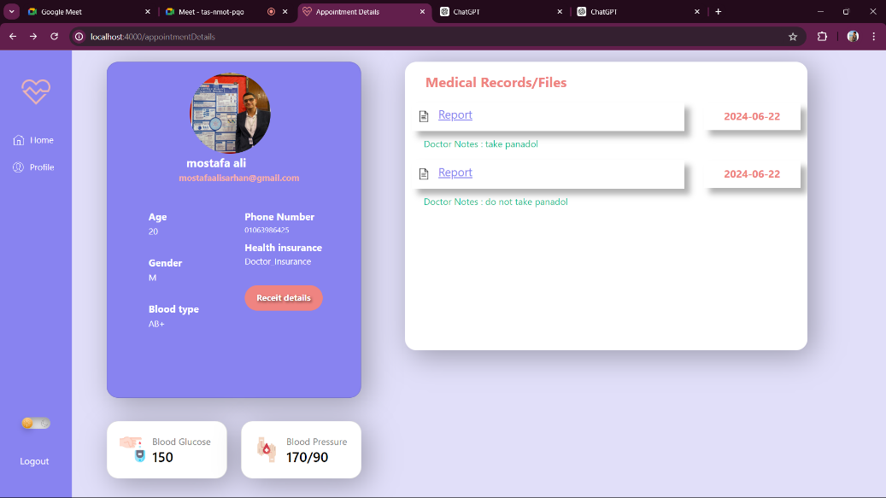

*Fig (19)*

When a doctor clicks on the "Details" button in their appointments, they are directed to a page (fig(19)) that contains details about the patient who scheduled the appointment.

#### Receipt:

*Fig (20)*

*Fig (21)*

*Fig (22)*

When the doctor clicks on the "Receipt Details" button on the patient details page, they are directed to a page where they can select from different scan types and medicines, shown in fig (20). We have implemented two entities for this purpose: one contains various scan types and the other contains different medicines. The system calculates the total cost based on their selections.

In addition, when the doctor selects medicines and scans, and clicks "Finish," a receipt is generated and sent to the patient's email as in fig (21) and fig (22)

The database maintains a record of medicine numbers. If a doctor attempts to add a medicine to the receipt that is out of stock, a message will appear indicating that the medicine is not available in the store, and the operation to add the medicine will not be completed. As shown in fig (23).

*Fig(23)*

#### Change Password:

*Fig (24)*

Users can change their password through this page as fig (24).

#### Drug Details:

*Fig(25)*

Admin can also track the number of drugs left in the stock as shown in fig (25).

## Future Work:

Given more time, we would like to incorporate the following features:

#### Responsive Website

We were in the process of making the website responsive using the Bootstrap library. However, we encountered some issues that prevented full functionality in certain cases. With additional time, we would address and resolve these issues to ensure the website is fully responsive across all devices.

#### Notifications Bar

We would implement a notification bar in the doctor’s profile. This feature would provide real-time updates on the doctor’s schedule, including who added or canceled an appointment.

#### Patient/Doctor Rating

We would introduce a rating system for both patients and doctors. Each time an appointment is canceled, the corresponding rating decreases, providing a feedback mechanism to improve reliability and accountability.